

Year 7 Transition – ICT Task 1

Classification of Dinosaurs

Learning Intention:

Success Criteria:

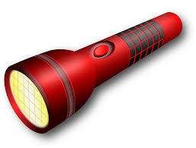
Clarify

What information are you looking for? Consider keywords, questions, synonyms,
alternative phrases etc.

- In the space below list the different types and parts of a dinosaur.

- How would you classify dinosaurs


Search

Research how dinosaurs are classified.

Use the following website and explain how dinosaurs are classified

https://www.enchantedlearning.com/subjects/dinosaurs/dinoclassification/

Make a classification key for the following dinosaurs.

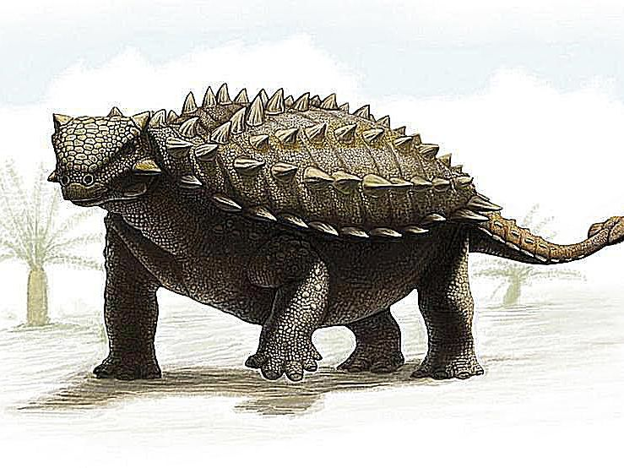

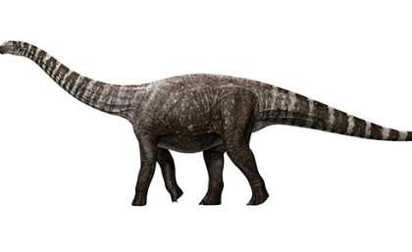

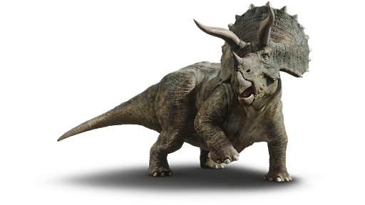

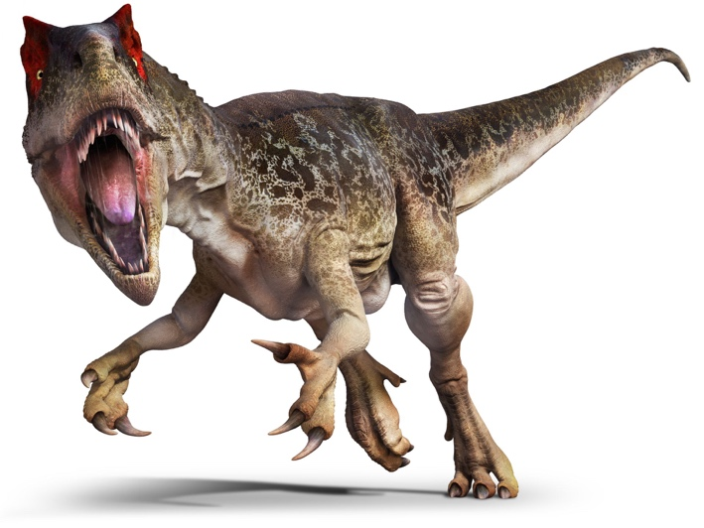
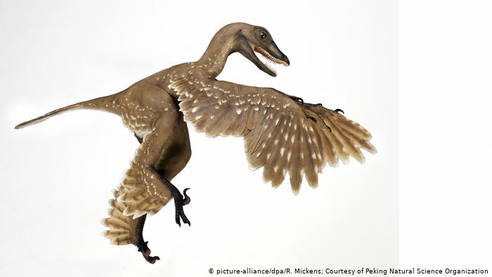

Evaluate

Use the original classifications to explain features of each of the above images.

Cite

Why must I cite my sources?
- I cannot claim the work or ideas of someone else as my own
- Plagiarism is not just when I directly copy words from someone else's work. Plagiarism is also when someone else's work is paraphrased or their ideas are used and claimed as my own
- Referencing has a positive effect and adds credibility to my work
- When I reference correctly, I am demonstrating that (a) I have read widely on the topic and (b) that I am supporting my hypotheses with comments from expert authors and/or reliable sources
- Correct referencing allows the marker/reader to follow-up my references and check the validity of my arguments for themselves.

Surname | Initial | Title of page | Full title of website | Date Written | Internet Address | Date of visit
Brown | J. | ‘Things in Space’ | Astronomy Facts | 1998 | http://www.astronomyfacts.com | 31 July 2019

